Name: ________________

ECE 101 LAB 3: DC MOTORS

- Overview
In this lab you will continue to gain experience with the lab equipment and building resistor circuits on the protoboard. The circuits you build this week will be used to supply power to run a DC motor.
As in the first lab, fill in the results and answer the questions right in this file (handout). You will turn it in online using the D2L Dropbox. You have up to one week after completing the lab to turn it in. Everyone needs to turn in an individual report. Your data should be the same as your partner’s but your text and sketches should be your own.
  - Pre-lab assignment
Read about DC motor operation here: http://www.howstuffworks.com/motor.htm. Review previous labs.
  - Laboratory objectives
This lab will focus on interaction between motors and circuits:
- To explore the relationship between voltage and current and the speed of a DC motor
- To design a circuit to run either two similar motors at different speeds or two different motors at the same speed

  - Equipment
By now, you will be familiar with most of these:
- Lab bench DC power supply, multimeter and computer
- ECE 101 lab kit with protoboard, wires, cables and assorted resistors (especially small values, 22 – 100 Ohms)
- Two DC motors (some groups will get two of the same size and some will get two different sizes)
- Cardboard for fan blades

  - Background
DC motors are in countless consumer products. Those in the lab were used in printers. There are different types of DC motors but they all work on the same basic principle. The motor contains a coil of wire in a magnetic field, and when current flows in the wire, the coil experiences a force which causes it to turn. For a better understanding of how motors work, here is a good, simple explanation: http://www.howstuffworks.com/motor.htm

- Lab assignments
In this assignment there will be a little bit more design involved. As usual, read the instructions carefully. You will first drive one motor and then two.
  - Single motor
- Construct fan blades out of thin cardboard and attach to the motors. This allows you to see and qualitatively judge how fast the motor is turning. Miscellaneous pieces of cardboard are available and there are several pairs of scissors shared throughout the room. Feel free to make any creative style of fan blades that you like! Make sure the blades do not obstruct the motor turning though.
- Build the circuit below with R₁ = R₂. These will need to be small resistors, between 22 and 100 Ohm. Use the larger motor if you have one.
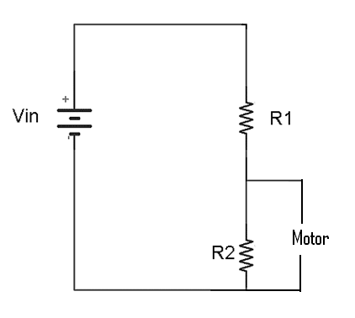
Figure 1. Schematic for a circuit driving a DC motor.
Hold the motor carefully so you will not be hit by the fan blades. Start with V_{in} = 1 V and gradually increase V_{in} until the motor begins to turn. You might need to give the fan blades a small push to get it going. Be careful not to increase the voltage more than you need; the small resistors will draw a lot of current and get hot! Some of these old motors are getting a bit “sticky.” If you are up to about 10 V and your motor is still not turning, try a different one. Measure the voltage V across the motor and the current through the motor at the point where the motor first starts to turn at a steady speed. Make sure you are measuring current in the motor, not in R₁ or R₂. Be careful to make the voltage and current measurements correctly; refer to the first lab or the equipment guides if necessary. Record the values below. Use mA for current.

- V_{in} _________________ V_{motor} _________________ I_{motor} _________________

- Repeat step 2) with R₁ replaced by (think about how you will accomplish this):
  - resistor approximately half the value and
  - resistor approximately twice the value
Keep R₂ the same, and adjust V_{in} as needed to get to the point where the motor first starts to turn at a steady speed. What do you conclude about the voltage and current required to run the motor?

- a) V_{in} _________________ V_{motor} _________________ I_{motor} _________________
- b) V_{in} _________________ V_{motor} ________________ I_{motor} _________________

- Return to your original R₁, and repeat step 2) to characterize the voltage and current needed to run your second motor.

- V_{in} ______________ V_{motor} ________________ I_{motor} _________________

  - Two motors
Design a circuit that allows two motors to run at the same time meeting the following condition:
- If your group has two similar motors , i.e., they run at about the same voltage and current, design the circuit so that one motor runs at approximately twice the speed of the other;
- If your group has two different motors, i.e., they run at quite different voltage and current, design the circuit so that the two motors run at approximately the same speed.
In either case, the problem is asking you to provide different voltage and/or current to the two motors. A suggestion: think about how you could use voltage or current division to control the voltage and current to the two motors.
In the space below,
  - Sketch your circuit neatly, including resistor values;
  - explain your design;
  - record appropriate voltage and current measurements;
  - show your circuit to the instructor or one of the TAs and have them initial the report

- V_{in} ______________ V_{motor1} ________________ I_{motor1} _________________
V_{motor2} ________________ I_{motor2} _________________

- Circuit sketch and explanation (do a sketch on a separate piece of paper, take a photo of it and include it in here; text should be written in Word):

- (Later) Discussion: Discuss here what you observed and any comments you have on this experiment. Please reflect on your learning experience – what helped your learning and what detracted from it.

