Name: ________________

ECE 101 LAB 5: DIGITAL LOGIC & NAND GATES
- Overview
In this lab you will examine an entirely different type of electrical circuits, those that rely on logical operations and deal with discrete values – “0” and “1” – instead of continuous range of values.

  - Pre-lab assignment
Review previous labs especially operation of lab equipment listed below. Do you know where you can find instructions for their use?

  - Lab objectives
You should gain experience dealing with digital circuits and logic. More specifically, you will:
- Test basic digital circuit operation
- Design, build and test more complex digital circuits

  - Equipment
Except for LEDs and NAND gate chip you should be familiar with all of these:
- Lab bench DC power supply, multimeter, signal generator, oscilloscope and computer
- ECE 101 lab kit with protoboard, wires, cables, resistors (2 x 1 kOhm), 2 LEDs (the red bulbs) and a quad 2-input NAND gate (the large rectangular chip)
Note: unlike resistors, LEDs (light-emitting diodes) have polarity (+ and – side) and must be connected correctly to operate. The + side will have a longer leg and/or the - side will have a flat spot.

  - Background
In digital circuits, we deal with signals that are either 0 (low voltage, off state) or 1 (high voltage, on state.) In this lab we will use 5 V for a logic 1 and ground for a logic 0, a common system. We’ll display the signal with an LED that is on for 1 and off for 0.
Logic operations such as AND, OR, NAND, NOR and NOT follow certain rules that are summarized in truth tables. See the class notes (“Digital”) for descriptions of these operations. The circuits that perform these operations are called logic gates. In this lab we’ll verify the operation of a NAND gate, and use NAND gates to build a voting machine.
- Lab Assignments
First two assignments deal with simple digital circuit testing, while the third one deals with more complex digital circuit design and test.

  - Build logic state indicator
You will use this circuit to test if a particular point is in “high” or “low” state (“1” or “0”)
- Build and test an LED logic indicator, as shown below.
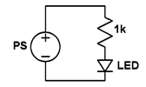
Figure 1. Simple logic state tester schematic.

- What PS voltage is required to turn the LED on? ____________

- Use multimeter to measure LED voltage and enter the value: ____________

  - Test NAND gate logic
The quad chip in the lab kit has 4 NAND gates with independent inputs and outputs, plus a common power supply “VCC” and ground. The pinout is shown on the left below. For example, the first NAND gate has two inputs (1A and 1B) connected to pins 1 and 2, and an output (1Y) connected to pin 3, as shown on the right below. This is showing the upper left corner of the chip. The other three gates are labeled similarly.
- Set up the chip on the protoboard with the VCC and ground connections. Set VCC to 5 V. Do not apply any voltages > 5 V to the chip!
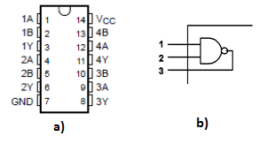
Figure 2. a) Pinout of NAND quad chip, and b) NAND gate circuit schematic.
Inputs: 1A, 1B, 2A, 2B, 3A, 3B, 4A, 4C
Outputs: 1Y, 2Y, 3Y, 4Y
GND: Ground
V_{CC}: Voltage Supply

- Using one of the NAND gates with your logic indicator connected to the output, verify the NAND truth table below by manually connecting the inputs alternately to VCC (“1”) and ground (“0”) in all four combinations. Note: input = 0 needs to be physically connected to ground, not just left open.
A B OUT
0 0 1
0 1 1
1 0 1
1 1 0

- If the inputs are connected together (A = B) what logic function does the gate perform? ___________

- Connect the inputs together (A=B) and connect them to the output of a signal generator we used in lab 4. Set the generator to output a 3 Vpp square signal with a repetition rate of your choice, say around 1 kHz. Set up the generator to output this signal on both channels. One of the channels will drive the NAND gate while the other is connected to oscilloscope on CH1. Connect the output of the circuit to CH2 on the oscilloscope. Set the oscilloscope up so that both waveforms are visible at the same time.
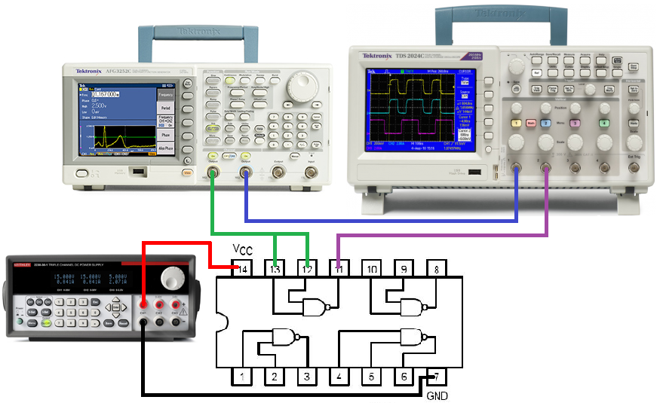
Figure 3. Circuit connections for testing the NAND gate.

- What do you observe? What function does this correspond to? _____________________________

  - Build and test more complex logic circuit
For an example of a logic circuit, we will build a voting machine. Use two logic indicators (two LEDs) to represent the two candidates X and Y. If X or Y gets more votes, LED X or LED Y will turn on, respectively. If there is a tie, both LEDs will turn on. To keep it simple, we will only have two voters, A and B. Let a 0 be a vote for X and 1 be a vote for Y.

- Think this through and verify that this truth table is correct. Contact your TA if you have any questions
A B X Y
0 0 1 0 2 votes for X, X wins
0 1 1 1 1 vote each, tie
1 0 1 1 1 vote each, tie
1 1 0 1 2 votes for Y, Y wins
Output X is simply . Output Y is A + B. Using the mathematical theorems of Boolean algebra, it can be shown that A + B = . (This is more math than we get into in this class, but you can write out the truth tables and see that it works. Ask me if you want to see the math.) So we can build this circuit with the four NAND gates on our chip: one for X, one for , one for and one for Y.

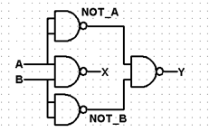
Figure 4. Circuit implementation of our "voting" logic.

If you want, you can use logic.ly program shown in class to simulate this circuit. http://logic.ly/demo/

- Build and test the circuit. Check it carefully before turning on the power. Remember you will need two logic indicators for X and Y. Test all four combinations of A and B. Have one of the TAs or the instructor check out your circuit.

- Describe your observations and comments on this lab below. And don’t forget to feel proud of yourself - this is a complicated wiring job you just accomplished!

- Please reflect on your learning experience – what helped your learning and what detracted from it?

